Letter of Intent (LOI)
For Franchise Grant – ALLDONE LAUNDROMAT --

Date: / / 2026
Subject: Grant of Franchise – AllDone Laundromat ( ) at

District : – - Pin ;-
To,
M/S ,Mr. , Ms Address:

Dear Sir/Ma’am,
We acknowledge your interest in becoming a Franchise Partner for AllDone Laundromat, registered Business Trade Name as , Aadhar No. / GST No
Place of work :- at and are pleased to consider your request for establishing an outlet at the proposed location . Kindly find below the key terms and conditions governing the grant of this franchise:

1. Franchise Term
The initial franchise term shall be five (5) years from the date of execution of the Franchise Agreement. Renewal shall be based on mutual agreement and the terms of the said Agreement.

2. Brand Fee (One-Time)
A one-time Brand Fees of INR 1,80,000 + applicable taxes is payable at the time of signing the Franchise Agreement & Marketing funds of Rs 1.2 Lac manage by Licensor .
- This includes:
  - ERP access & on boarding (Dedicated Landing Page, Mob. Apps, Billing Software & CRM)
  - One celebrity promotional video
  - Three influencer campaigns (with paid boosts)
  - Operations manual, training & digital on boarding support
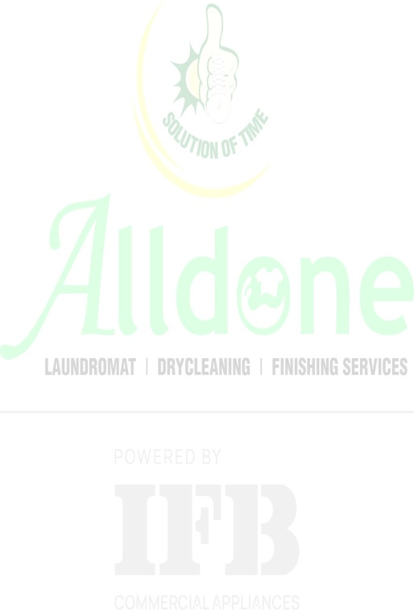
  - GMB , Dedicated Instagram & Facebook Page , WhatsApp AI

3. Machinery & Store Setup Cost

IFB Machinery Cost: As per quotation 6.78 Lac + applicable taxes (Dispatch within 10 days after advance payment .( Since Franchise partner is interested to installed Gas Dryer hence price difference will be paid separately )
- Store Setup Cost: Approx. INR 2 Lac (on actual through local vendors).

- AllDone Support: MEP drawings, store layout (2D/3D), and site supervision.

4. Marketing & Royalty Structure
- Initial Marketing Commitment: Franchisee for the first 3-4 months till Op.BEP (Operational Break Even Point )
- Execution: AllDone Marketing Team runs centralized campaigns (SEO, GMB, Instagram, Facebook, WhatsApp API).
- Franchisee Role: Recharge ad accounts directly; AllDone Mkt. Team will provide weekly reports.
After break-even:
- Option 1: Continue with AllDone-managed marketing → Royalty 7% of revenue
- Option 2: Manage marketing independently (with AllDone support) → No royalty, only sale’s funnel recharge

5. Earnest Money Deposit (EMD)

Total EMD: Total EMD :₹1,18,000 (Incl. Taxes)
Received: ₹ 21,000 Location Singing Amount via UTR No. [ ] , Dated / /2026 , Balance Payable LOI amount :₹97,000 by NEFT No.[ ] Dated / / 2026 .
- Adjustable against Brand Fee at the time of Franchise Agreement.
- If the Franchise Agreement is not signed within 30 days, the EMD is refundable. Post this period, no refund will be entertained.

6. Location Approval
All proposed sites are subject to approval by AllDone & Regional Master Franchisee, based on:
- Demographics
- Lease terms
- Accessibility & visibility
- Compliance with brand standards
- Feasibility study

7. Franchise Agreement Execution
The draft Franchise Agreement will be issued within 20 days of this LOI. It must be signed within 5 days of receipt, subject to full payment of the Brand Fee.

8. Operational Launch Timeline
- Store launch must occur within 30 days of agreement signing.
- Dedicated staff room with kitchen utilities is mandatory.
- Final approval for launch will be provided by the Regional Master Franchisee post inspection.

9. Branding
- All branding to be executed by AllDone-authorized vendors.
- Branding cost will be borne entirely by the franchisee.

10. Transportation & Logistics
All costs related to transportation, logistics, and freight of equipment and materials will be borne by the franchisee.

11. Operations & Quality Assurance
- Turnaround Time (TAT): 24 hours (as per SOP).
- CCTV: Mandatory; footage must be made available to AllDone team on demand.
- Garment Check: Store Manager responsible at drop-off counter.

12. Staff & Compliance
- Laundry staff arranged via AllDone recruitment; Front Office Executive appointed by franchisee.
- Staff salaries & incentives to be disbursed by the 10th of every month.
- All employees must wear AllDone ID cards.
- Franchisee must obtain GST registration as per Section 24 (VII), CGST Act, 2017.

Additional Terms & Clarifications
- Electricity Connection Requirement
The Franchisee shall be solely responsible for arranging a minimum 15 kW electricity connection at the proposed outlet prior to installation of equipment. This requirement is mandatory for operations and is not included within the business model or financial calculations provided by the Franchisor.
- Security Deposit & Advance Rent
The security deposit and/or advance rental payment for the outlet premises shall be borne by the Franchisee separately, in accordance with the valuation and requirements of the property owner/landlord. These payments are outside the scope of the business model and therefore are not calculated in the financial projections shared by the Franchisor.

13. Payment Details
- Bank Name: IDFC FIRST Bank
- Account Name: AllDone Asiatic Solutions Pvt. Ltd.
- Account No.: 10178161449
- Branch: Lucknow (Munshi Pulia)
- IFSC Code: IDFB0021255

14. Acknowledgement & Confirmation
Please acknowledge your acceptance of the above terms by signing and returning this LOI. The signed LOI shall confirm your intent to proceed toward formal franchise engagement.

For ALLDONE LAUNDROMAT
Authorized Signatory: ……………………
Date: ……………………

Signature & Seal: ……………………

For Franchise Applicant
I/We hereby acknowledge and accept the terms of the above Letter of Intent.
Authorized Signatory (Applicant’s Name): ……………………
Date: ……………………
Signature & Seal: ……………………

